|  |  |
| --- | --- |
|  | **CONSULATE GENERAL OF THE REPUBLIC OF BULGARIA**  **IN NEW YORK** |

**NEWSLETTER – FEBRUARY 2024**

You are welcome to the following events in and around New York, co-organized by the Bulgarian Consulate General in New Yor and/or including representatives of the Bulgarian community in the Northeastern US:

* February 3rd, 3.30 pm: **Angela Rodel,** the 2023 International Booker Prize-winning translator, will participate in a literary event at **Columbia University** “The Discreet Monsters of the Past”. She will be joined by Harriman Institute Director Valentina Izmirlieva, who will read the texts in her native Bulgarian.Address: Columbia University, Harriman Institute Atrium, 12th floor International Affairs Building, 420 W 118th St New York. Language: English.

• February 3rd, 7.30 pm: **A stand up comedy** show “Тъп оптимист“ with Yavor Borisov. Language: Bulgarian. Address: **Mehanata Bulgarian Bar**, 113 Ludlow St., New York, NY 10002.

* February 3rd, 8.30 pm: A musical performance by **Vlada Tomova and Yasna Voices**. Language: English. Address: 85 Avenue A, New York, NY 10009.

* February 4th, 3 pm: **Bulgarian Folk Dance Shop**, organized by **Bulgarian School Hristo Botev**, New York. Address: 315 W 18th St, 6 fl. NY, NY 10011.

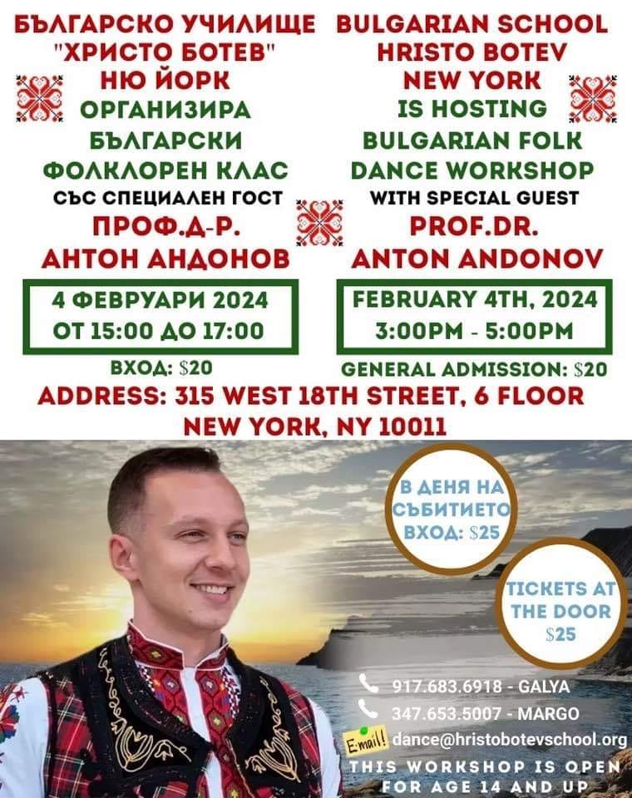

* February 7th, 7 pm: **Bulgarian Dance Party**. Come dance to the bagpipe! Lubomir Smilenov - gaida, gadulka, Michael Ginsburg – tupan. Brief instruction for the dances. Address:213 E 82nd St, NY, NY 10028. Info: 646-831-8720 85.

* February 11th, 4 pm: **Sofia Philharmonic in New York**. Language: English. Address: Lehman Center, 250 Bedford Park Blvd West, **Bronx**, New York 10468.

* February 14th, 6:30 pm: **Flute and Piano Duets, organized by Bulgarian Concert Evenings in New York.** Performers:Lora Al-Ahmad, piano and Maron Khoury, flute. Book athttps://www.bceny.org/season-2023-24. Address: **Consulate General of Bulgaria in New York**, 121 E 62nd St, New York. Language: English.

* February 15th, 7 pm: **A Comedy Show of Mihail Bilalov**. Language: Bulgarian. Address: 590 Main St., **Melrose, MA**.

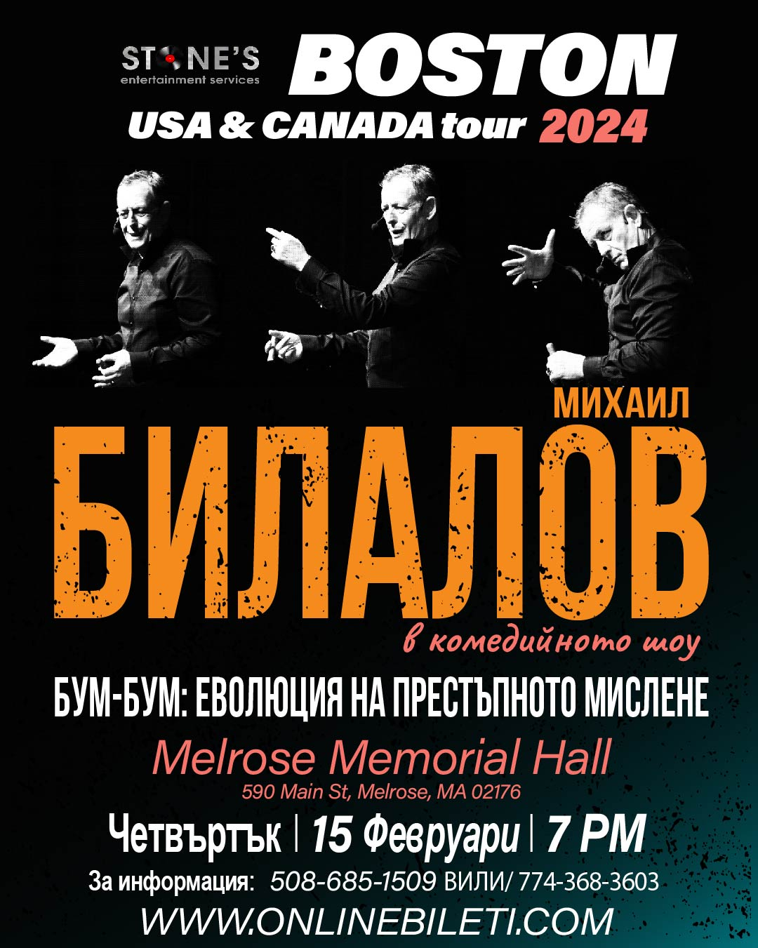

* February 16th, 6 pm: **Horoteka NYC** with Elissaveta and Guergana. Address: **KTown Dance Studio**, 38 W 32nd St, New York, NY 10001.

* February 17th, 7 pm: **Sofia Philharmonic in New Jercy**. Language: English. Address: **State Theatre New Jersey**, 15 Livingston Avenue **New Brunswick**, NJ 08901.

